This is a Robotic Process Of automation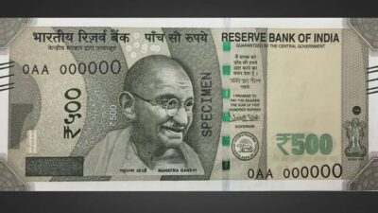

New Version Of PRA.